Tangled Lives
Resource for worship week 16

You will need a cross and some tangled wool or string

Opening verse:
Trust in the Lord with all your heart and lean not on your own understanding. In all your ways acknowledge him and he will make your paths straight.’ Proverbs 3:5,6

Read through slowly the familiar verses from Lamentations 3:19-26 below:

¹⁹ I remember my affliction and my wandering, the bitterness and the gall.
²⁰ I well remember them, and my soul is downcast within me.
²¹ Yet this I call to mind and therefore I have hope:

²² Because of the Lord’s great love we are not consumed, for his compassions never fail.
²³ They are new every morning; great is your faithfulness.
²⁴ I say to myself, “The Lord is my portion; therefore I will wait for him.”

²⁵ The Lord is good to those whose hope is in him, to the one who seeks him;
²⁶ it is good to wait quietly for the salvation of the Lord.

Reflection:
As restrictions begin to lift, many of us are beginning to see light at the end of the tunnel. We recognise there is still a long way to go but we can look back and see how far we have come – and we can give thanks to the Lord for bringing us thus far.
Yet many of us have not come through unscathed, for we have missed important events, we have reluctantly had to cancel trips and holidays, we have been kept from attending church, we have been living with constant anxiety and in some cases we have lost loved ones and not been able to be with them in their darkest hour.
Friday 17th July marks the 5th anniversary of the Bosley Mill explosion, when four people tragically lost their lives and many more were injured physically and emotionally. The wait goes on for answers, and the loss never goes away.
This week Phil spoke of our Lord’s promise of rest and peace; his call to us to take upon ourselves his yoke and to lay our burdens upon him who loves us. For ‘because of the Lord’s great love we are not consumed, for his compassions never fail. They are new every morning, great is your faithfulness.’
The Lord is always here for us and he will bless us again with his love. He keeps his promises and his word will not fail. We need only to wait patiently for his salvation and look to him in faith and trust.

Prayer Activity
Take the tangled wool or string. Consider how easily it seems to become tangled and knotted. Like our lives which one moment seem all neat and tidy and the next, without us doing anything major, seem to become a complicated network of knots and entanglements that refuse to be undone. Begin slowly to untangle the wool and free the knots. Reflect on the patience and thought required and the need to focus. So the Lord works gently, patiently in our lives, loosening the knots, unpicking our problems, making our ways straight. When we struggle and squirm we only make the task harder and make the tangles tighter. When we rest in him, trusting in his wisdom, relying on his love, we find ourselves working with him and our lives become easier.
Take a moment to give to the Lord the knotty problems and entanglements you have in your life. Commit your ways to him and pray for patience to rest in his purposes.

You may wish to pray the following prayer:

Lord Jesus,
As I reflect on my life,
the choices and decisions I need to make,
I feel confused, overwhelmed, frustrated, bewildered.
Everything is interconnected, nothing is clear,
All paths seem to lead to more problems not less.
You said my life was a tapestry that you were weaving,
But I see only knots and tangles that threaten to break the thread.
Master weaver, unpick and untangle my life,
Make my ways straight and my path clear.
Help me rest in your will and to wait in patience
For your glorious purposes to appear in my life. Amen.

Patience - Justin Farley

The agony of waiting, watching the hours
Drains my power and leaves me bitter
Filled with battered pride and endless angst.
But just as it takes a season to cultivate a flower,
I must keep a steadfast heart and wait.

My deepest failure is relying on my own two hands
To control, conquer, defend, and prevent defeat.
For when I am solely responsible for the success of all life’s plans,
My heart lies anxious constantly, consciously looking
To deter life’s inevitable outcomes with each and every beat.

It is in waiting, humbly praying, admitting
That you and you alone know the matter of my fate,
That my anxious and impatient heart can rest
Trusting you know what’s best and patiently, pridelessly wait.

Time of prayer
Let us pray to the Lord,
who is our refuge and stronghold.
For the health and well-being of our nation,
that all who are fearful and anxious
may be at peace and free from worry:
Lord, hear us,
Lord, graciously hear us.
For the isolated and housebound,
that we may be alert to their needs,
and care for them in their vulnerability:
Lord, hear us,
Lord, graciously hear us.
For our homes and families,
our schools and young people,
and all in any kind of need or distress:
Lord, hear us,
Lord, graciously hear us.
For a blessing on our local community,
that our neighbourhoods may be places of trust and friendship,
where all are known and cared for:
Lord, hear us,
Lord, graciously hear us.
For ourselves that we might find peace in our lives
and know your presence with us in all we do.
Lord, hear us,
Lord, graciously hear us.

We commend ourselves, and all for whom we pray,
to the mercy and protection of God.
Merciful Father,
accept these prayers
for the sake of your Son,
our Saviour Jesus Christ. Amen.

Almighty and everlasting God
By whose Spirit the whole body of the Church
Is governed and sanctified:
Hear our prayer which we offer for all your faithful people,
That in their vocation and ministry
They may serve you in faithfulness and truth
To the glory of your name.
Through our Lord and Saviour Jesus Christ. Amen.

Let us commend ourselves and all for whom we pray
to the mercy and protection of God, in the prayer our Saviour taught us.

Our Father who art in heaven,
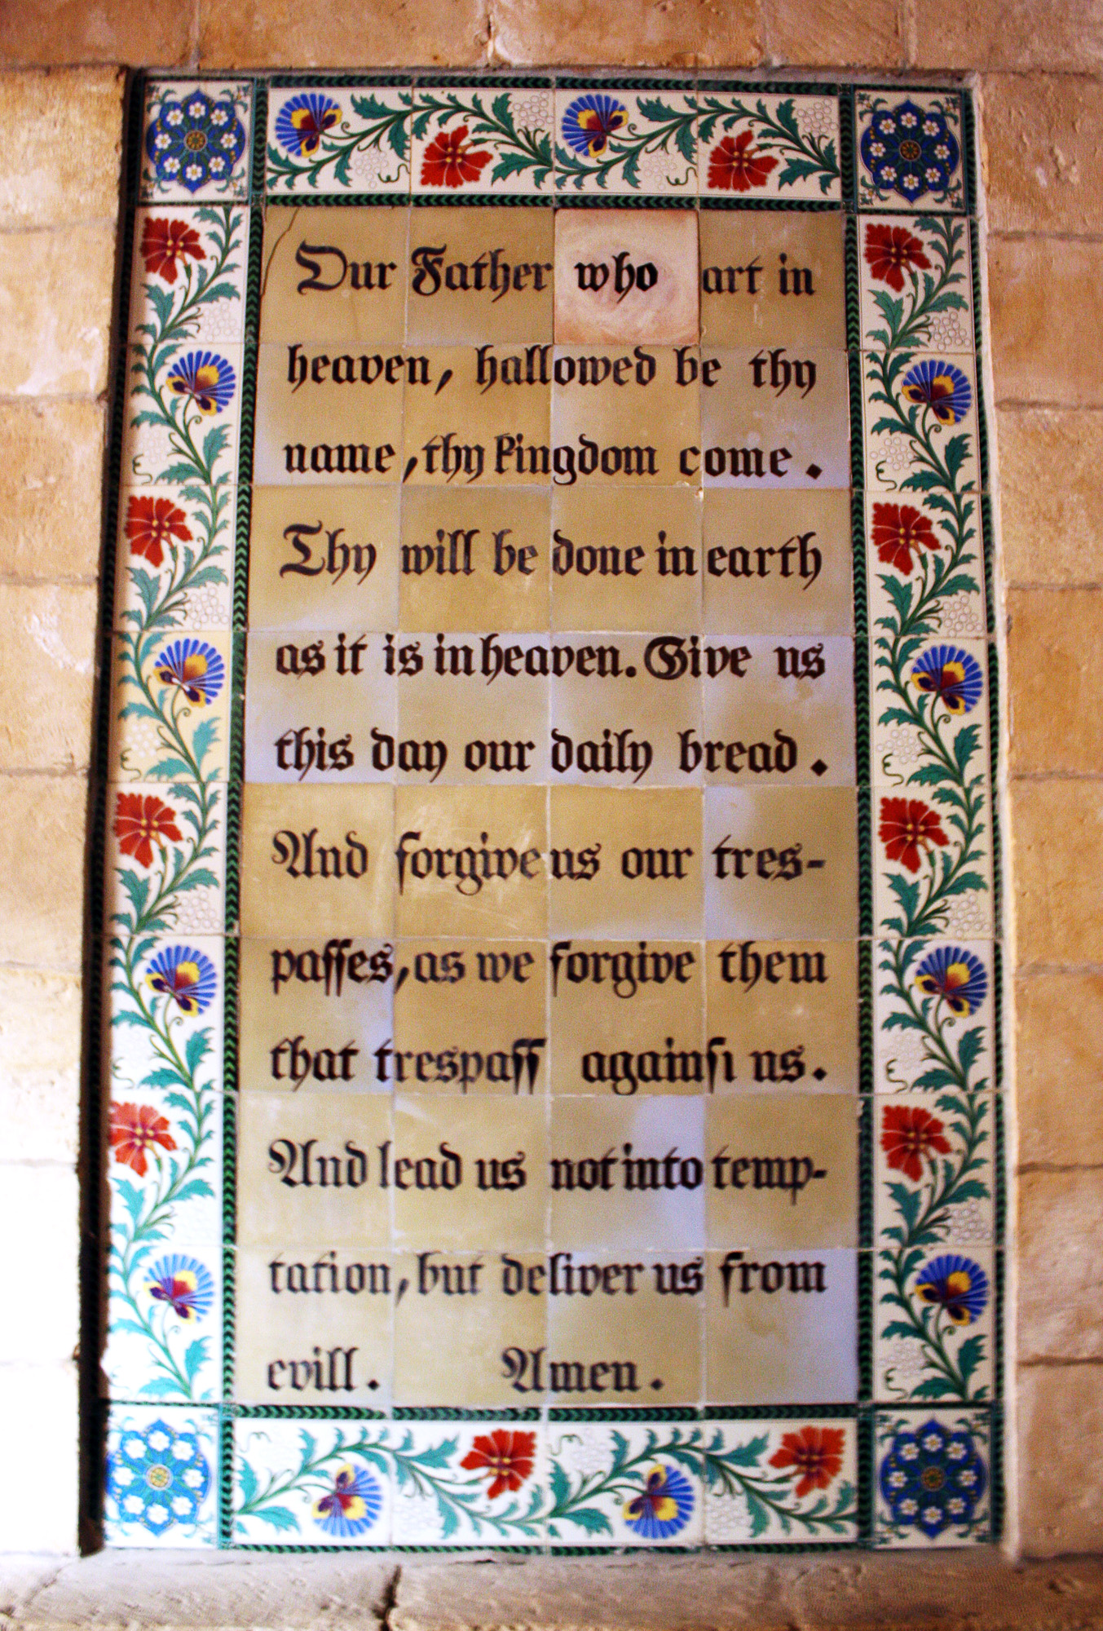
Hallowed be thy name.
Thy kingdom come,
thy will be done on earth as it is in heaven.
Give us this day our daily bread
and forgive us our trespasses
As we forgive those who trespass against us.
And lead us not into temptation
but deliver us from evil
For thine is the kingdom,
the power and the glory
For ever and ever. Amen.

A song to sing or reflect on:

Be still for the presence of the Lord
The Holy One is here,
Come bow before Him now
With reverence and fear
In Him no sin is found
We stand on holy ground
Be still for the presence of the Lord
The Holy One is here.

Be still for the glory of the Lord
Is shining all around;
He burns with holy fire
With splendour He is crowned:
How awesome is the sight
Our radiant King of light!
Be still for the glory of the Lord
is shining all around.

Be still for the power of the Lord
Is moving in this place
He comes to cleanse and heal
To minister His grace.
No work too hard for Him
In faith receive from Him
Be still for the power of the Lord
is moving in this place.

Closing prayers
You are called and loved by God the Father
And kept safe by Jesus Christ.
Mercy, peace and love be yours in abundance
From God the Father, Son and Holy Spirit. Amen.

