Letters on our hearts

Resource for worship week 14
You will need a cross and a letter to or from a loved one

Opening verse:
‘It is right for me to feel this way about all of you, since I have you in my heart… all of you share in God’s grace with me.’ Philippians 1:7

Read through slowly the verses from 2 Corinthians 3:1-3 below:

¹Are we beginning to commend ourselves again?
Or do we need, like some people, letters of recommendation to you or from you?

² You yourselves are our letter, written on our hearts, known and read by everyone.

³ You show that you are a letter from Christ, the result of our ministry, written not with ink but with the Spirit of the living God, not on tablets of stone but on tablets of human hearts.

Reflection:
After more than three months in lockdown, separated from friends and family, we are all craving human contact. We long to be back together again, to hear own individual stories and to rejoice in one another. But, although we are closer to that day, we must be patient for a little while longer. More than ever we have come to rely on social media, the telephone and of course letters to keep in contact. Letters are especially important for they enable us to communicate in a deeply personal way, from heart to heart. I still remember my mum waiting eagerly for weeks, even months, to receive an airmail from her brother in Australia. She would drop everything to read it and find out how he was doing. I’m reminded too, when at university, how each morning, all of us would gather excitedly around the mailboxes to see if we had received news from home.

Paul speaks a lot about letters in our reading. He describes the Corinthian believers as a ‘letter written on his heart, known and read by everyone,’ and how in turn ‘they are a letter from Christ written by the Spirit on people’s hearts.’ These letters are living letters, forged through relationship, founded on trust and rooted in deep abiding love. They speak to the world not as uncompromising commands written on stone but as living truth, engraved on hearts full of compassion and mercy. He is saying that Christ is able to communicate his love for the world through the lives of those who love him.

Prayer Activity
Take your letter in your hands. Think of the person to whom or from whom the letter is addressed. Is the letter faded from being read over and over or is it pristine? Was it hand delivered or posted second class? What does it mean to you?
Imagine Jesus sending a letter to someone through you, from heart to heart. What is the Lord saying to you? How is his love made known to others through his letter on your heart?

You may wish to pray the following prayer:

Lord Jesus,
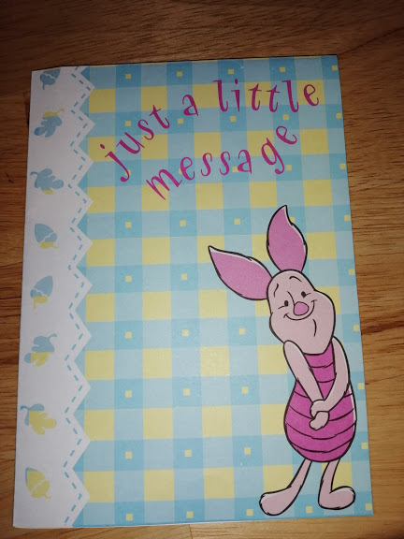
To you, my heart is an open book, a letter
in which you have written your words of love.
Over the years I have often read these words
Taken great comfort in them and been guided by them
This letter may now be faded, worn by use
but the truths therein are as fresh and vital as ever.
Lord, may your love for the world
Be seen, written on the pages of my heart,
A message from your heart to theirs,
For the glory of your name. Amen.

Quote from Mother Teresa:

I am a little pencil in the loving hands of God.

He does the thinking.

He does the writing.

He does everything

and sometimes it is really hard

because it is a broken pencil

and He has to sharpen it a little more.

Time of prayer

O God, the author and fountain of hope
Enable us to rely with confident expectation on your promises
Knowing that all things work to the good of those who love God.
Help us in all things to look to you
And the joy that is set before us,
that we may be steadfast in faith
and fervent in showing love to all in need.
Lord, in your mercy
Hear our prayer.

Lord Jesus
in this time of change and upheaval
Grant that the Church may hear your call
To step from the boat and launch out into the deep.
Give us courage before the waves that tower over us
And conviction that you are able to save
All who put their trust in you,
so we may proclaim your gospel fearlessly
and your kingdom may grow to the glory of your name.
Lord, in your mercy
Hear our prayer.

We pray for our local businesses and charities
As they seek to reopen following the lockdown.
We pray for employers and employees,
for those who have been put on furlough
And those who have lost their jobs during this crisis.
Support and direct, sustain and provide for all in need.
Lord, in your mercy
Hear our prayer.
We pray for our communities
As the restrictions ease and we are able to meet.
Keep us safe and vigilant to the dangers,
protect those who are most at risk
and restore to us our joy.
Lord, in your mercy
Hear our prayer.
We pray for those in isolation or alone
For those in care homes, hospices and hospitals
Those recovering and those who are becoming more frail
Visit them with your Spirit of healing,
Sustain them by your mighty power
And bless them with your love.
Lord, in your mercy
Hear our prayer.
Lord, we pray for those who are grieving,
That they may know your consolation and comfort,
Look upon them with peace and mercy,
Hear their cries and hold them close to your heart
Lord, in your mercy
Hear our prayer.

Let us commend ourselves and all for whom we pray
to the mercy and protection of God, in the prayer our Saviour taught us.

Our Father who art in heaven,
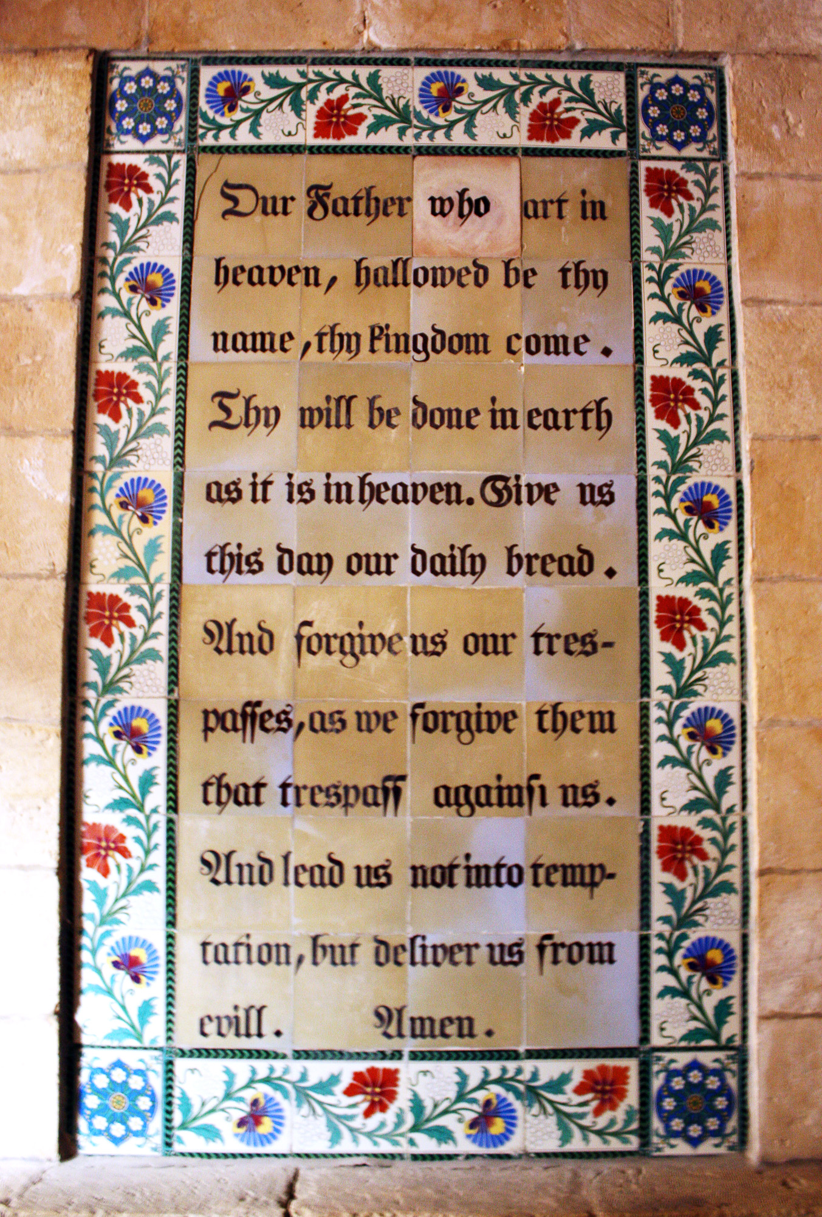
Hallowed be thy name.
Thy kingdom come,
thy will be done on earth as it is in heaven.
Give us this day our daily bread
and forgive us our trespasses
As we forgive those who trespass against us.
And lead us not into temptation
but deliver us from evil
For thine is the kingdom,
the power and the glory
For ever and ever. Amen.

A song to sing or reflect on:

Fill Thou my life, O Lord my God,
In every part with praise,
That my whole being may proclaim
Thy being and Thy ways.

Not for the lip of praise alone
Nor e’en the praising heart
I ask, but for a life made up
Of praise in every part.

Praise in the common things of life
Its goings out and in
Praise in each duty and each deed
However small and mean

Fill every part of me with praise
Let all my being speak
Of Thee and of Thy love O Lord
Poor though I am and weak

So shalt Thou, Lord, from me, e’en me
Receive Thy glory due
And so shall I begin on earth
The song for ever new.

So shall no part of day or night
From sacredness be free
But all my life, in every step
Be fellowship with Thee.

Closing prayers
Lord, you have brought us through this day
To a time of reflection and rest
Calm us, and give us your peace to refresh us.
Keep us close to Christ
That we may be closer to one another
Because of his perfect love
In his name we pray. Amen.

The love of the Lord Jesus
Draw you to himself
The power of the Lord Jesus
Strengthen you in his service
The joy of the Lord Jesus, fill your hearts,
And so may you be enfolded in the heart of God
This evening and for evermore. Amen.

