A beautiful thing

Resource for worship week 13
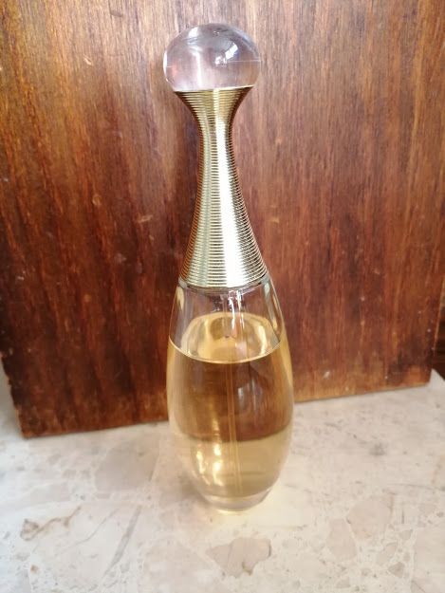
You will need a cross and a bottle of perfume

Opening verse:
‘My soul finds rest in God alone; my salvation comes from him.’ Psalm 62:1

Read through slowly the verses from Mark 14:3-7 below:

³ While Jesus was in Bethany, reclining at the table in the home of Simon the Leper, a woman came with an alabaster jar of very expensive perfume, made of pure nard. She broke the jar and poured the perfume on his head.
⁴ Some of those present were saying indignantly to one another, “Why this waste of perfume?
⁵ It could have been sold for more than a year’s wages and the money given to the poor.” And they rebuked her harshly.
⁶ “Leave her alone,” said Jesus. “Why are you bothering her? She has done a beautiful thing to me.
⁷ The poor you will always have with you, and you can help them any time you want. But you will not always have me.

Reflection:
We don’t know the motivations that sparked the outspoken criticism of the woman. Perhaps some of those present were jealous of the special attention Jesus was receiving. Maybe there was a genuine concern for the poor encouraged by Jesus’ own passion to reach out to the marginalized and outcasts of society. No doubt others did not believe Jesus was worthy of such extravagance or thought it unseemly to display such affection in public. Who was this woman? More importantly, who was this man to provoke such a response?
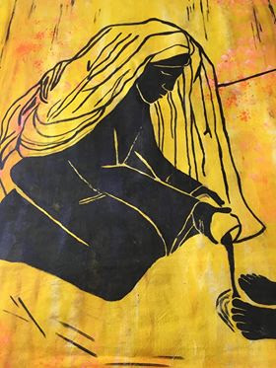
Mary anointing Jesus, by Rev. Dorothy Woods.
The woman anointed Jesus with the very best that she had because she loved the Lord more than anything else in the world. Jesus endorsed her action because it was fitting, for he is the Son of God, worthy of all our praise and honour and devotion. As Isaac Watts writes in his most loved hymn,
‘were the whole realm of nature mine,
it were an offering far too small.
Love so amazing, so divine,
demands my soul, my life, my all.’

The acid test of our faith in God is the outpouring of our love for Jesus. How dear is he to our hearts? How much do we love the Lord?

Prayer Activity
Reflect on our reading once more. Picture yourself in the room with Jesus. Perhaps you are one of the disciples, or an onlooker, or Simon, or even the woman herself. Imagine the scene as Jesus is anointed and everyone is staring. What are you thinking and feeling?
You hear Jesus say, ‘She has done a beautiful thing to me. The poor you will always have with you, and you can help them any time you want. But you will not always have me.’ What is your response?
Hold in your hand your bottle of perfume. Think about why you bought it, why you chose that particular brand. Think about the Lord. What would you do, what would you give to show how much you love him?
You may wish to pray the following prayer:

Lord Jesus, you are more lovely and more worthy
Than anything else in all creation.
You are my light, my joy, my hope and my life.
I give to you this day,
my body, my soul, my heart, my strength, my all,
I offer you my work, my friends, my wealth and my life,
For you to use as you see fit.
Accept this small offering as a token of my love
And the sacrifice of my worship
For my Lord and Saviour, Jesus Christ. Amen.

Poem: Anointing at Bethany by Malcolm Guite

Come close with Mary, Martha, Lazarus
So close the candles stir with their soft breath
And kindle heart and soul to flame within us
Lit by these mysteries of life and death.
For beauty now begins the final movement
In quietness and intimate encounter
The alabaster jar of precious ointment
Is broken open for the world’s true lover,
The whole room richly fills to feast the senses
With all the yearning such a fragrance brings,
The heart is mourning but the spirit dances,
Here at the very centre of all things,
Here at the meeting place of love and loss
We all foresee, and see beyond the cross.

Time of prayer

Gracious God, fountain of all wisdom
We pray for your church in this land;
For our Archbishops Justin Welby and Stephen Cottrell,
our diocesan bishops Keith and Mark and all Christian leaders.
We pray your word may dwell richly in our hearts
And that, as the family of God,
we may be knit together in love and in truth
Lord, in your mercy
Hear our prayer.

We pray for the leaders of the nations
And for those in authority under them,
Thinking especially of our own United Kingdom.
Give them the gift of your wisdom and
a right discernment in all things.
Guide them in justice to uphold the rights
Of the poor and the marginalised,
That all might be valued and respected
Whatever their race, colour or ethnicity.
Lord, in your mercy
Hear our prayer.

We pray for our communities
In Sutton, Bosley, Wincle and Wildboarclough,
For those who live and work here,
And for those who visit.
Speak your word of peace in our midst
And help us to serve one another
As we would serve you, O Lord.
Lord, in your mercy
Hear our prayer.
We pray for those who do not believe in you
Or love you as their Lord and Saviour,
And yet they long to know you and the life you offer.
Open their eyes to hear your voice,
And open their hearts to receive your love.
Lord, in your mercy
Hear our prayer.
We pray for those bowed down with grief, fear or sickness
Especially at this time of enforced isolation:
May your living word bring comfort and healing
And may your Spirit anoint them with peace and hope.
Lord, in your mercy
Hear our prayer.

Let us commend ourselves and all for whom we pray
to the mercy and protection of God, in the prayer our Saviour taught us.

Our Father who art in heaven, Hallowed be thy name.
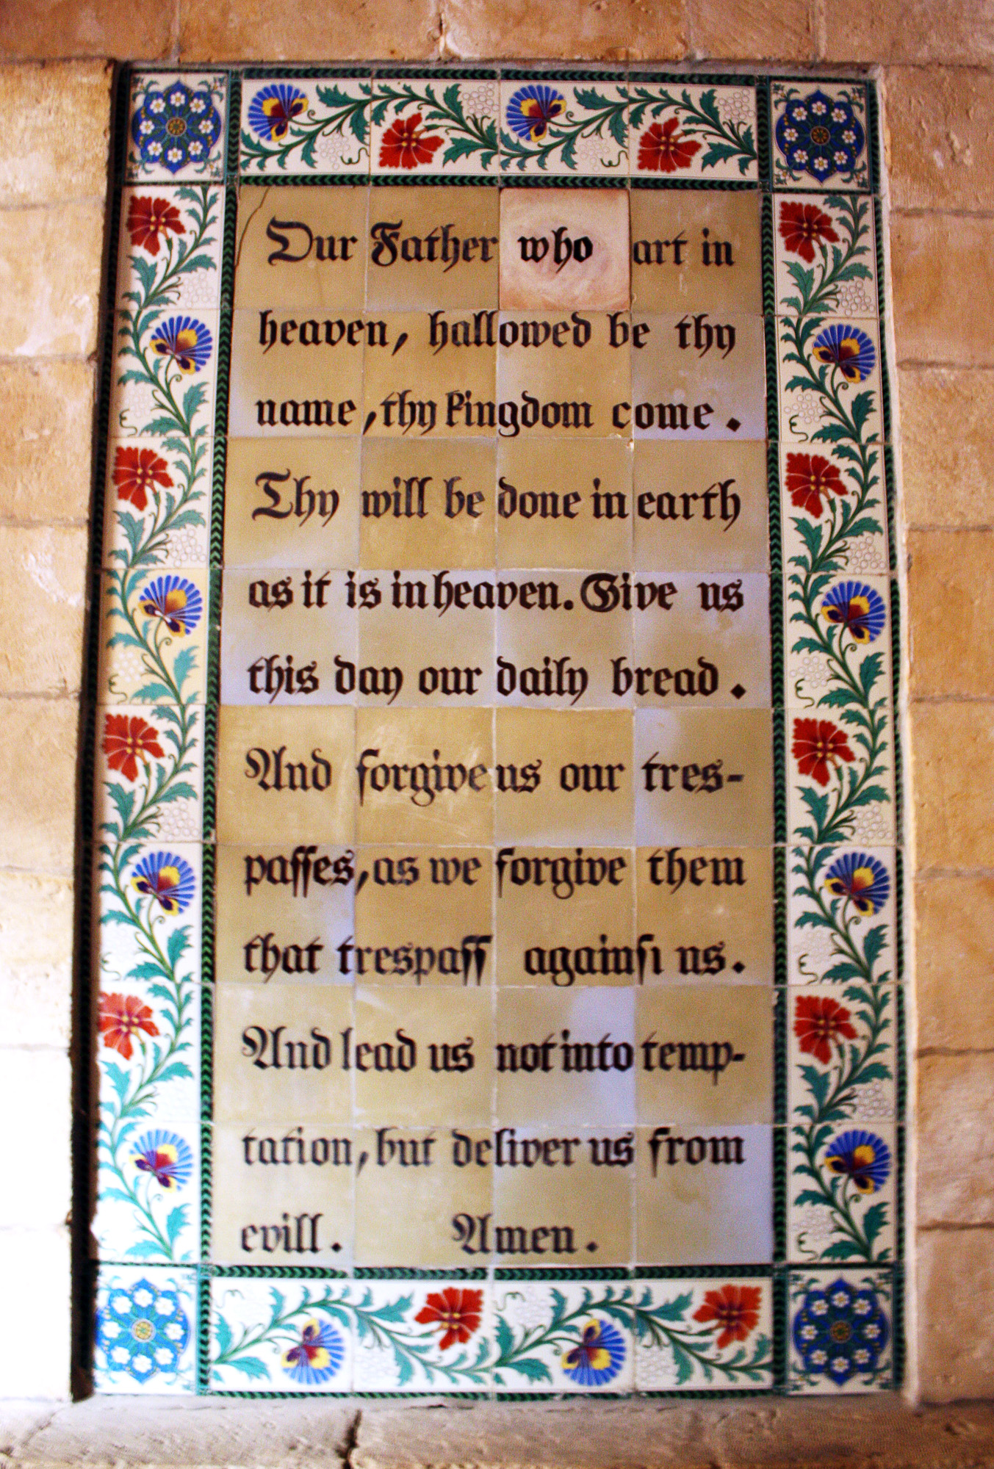
Thy kingdom come, thy will be done on earth as it is in heaven.
Give us this day our daily bread and forgive us our trespasses
As we forgive those who trespass against us.
And lead us not into temptation but deliver us from evil
For thine is the kingdom, the power and the glory
For ever and ever. Amen.

A song to sing or reflect on:

Take my life and let it be
Consecrated Lord to Thee
Take my moments and my days
Let them flow in ceaseless praise.

Take my hands and let them move
At the impulse of Thy love
Take my feet and let them be
Swift and beautiful for Thee.

Take my voice and let me sing
Always, only for my King
Take my lips and let them be
Filled with messages from thee.

Take my silver and my gold
Not a mite would I withhold
Take my intellect and use
Every power as Thou shalt choose.

Take my will and make it Thine
It shall be no longer mine
Take my heart, it is Thine own
It shall be Thy royal throne.

Take my love, my Lord I pour
At Thy feet its treasure store
Take myself and I will be
Ever only all for Thee.

Closing prayers
God of our salvation
You have restored us to life
You have brought us back again into your love
By the triumphant death and resurrection of Christ
Continue to heal us and restore us
As we go to live and work
In the power of your Spirit
To your praise and glory. Amen.

The Lord bless you and watch over you
The Lord make his face shine upon you
And be gracious to you
The Lord look kindly on you
and give you peace. Amen.
Mary anointing Jesus, by Rev. Dorothy Woods

