Using our talents

Resource for worship week 6

You will need an item that symbolises a gift or talent you have and a cross.

Opening verse:
‘I have not stopped giving thanks for you, remembering you in my prayers.’ Eph. 1:16

Read through slowly the verses from Romans 12:4-12 below:
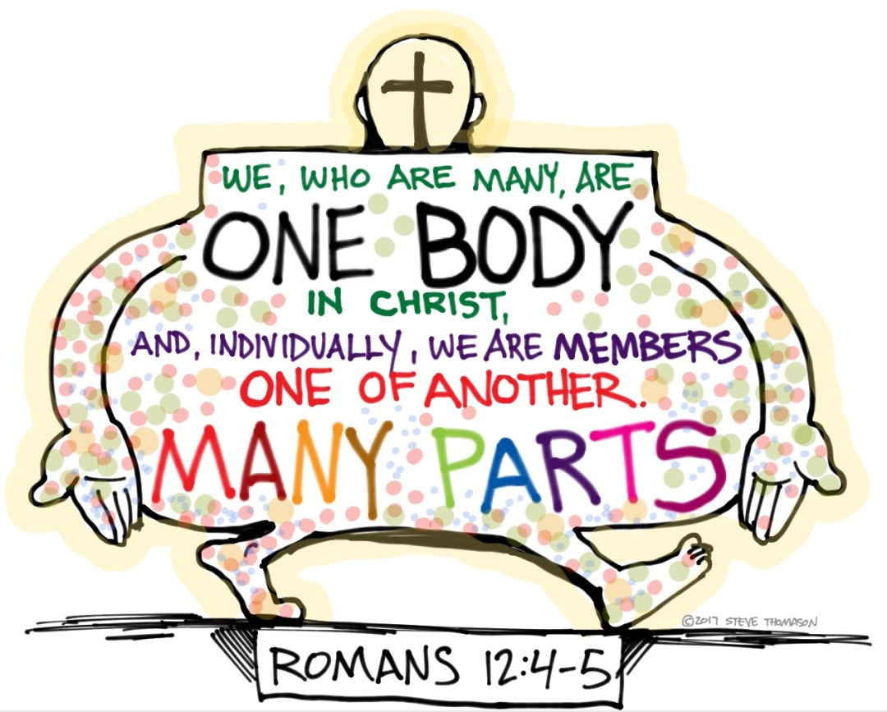
⁴ For just as each of us has one body with many members, and these members do not all have the same function, ⁵ so in Christ we, though many, form one body, and each member belongs to all the others. ⁶ We have different gifts, according to the grace given to each of us. If your gift is prophesying, then prophesy in accordance with your faith; ⁷ if it is serving, then serve; if it is teaching, then teach; ⁸ if it is to encourage, then give encouragement; if it is giving, then give generously; if it is to lead, do it diligently; if it is to show mercy, do it cheerfully.
⁹ Love must be sincere. Hate what is evil; cling to what is good. ¹⁰ Be devoted to one another in love. Honour one another above yourselves. ¹¹ Never be lacking in zeal, but keep your spiritual fervour, serving the Lord. ¹² Be joyful in hope, patient in affliction, faithful in prayer.

Reflection:

As members of one body, our God has called us to be mutually dependent upon one another. If one of us suffers, all of us suffer with them; if one of us is encouraged, all of us are blessed. What a privilege to be given gifts that can be a blessing to others, to see them growing and rejoicing because of our service.

During this time of lockdown it is very easy to feel isolated and to think there is little that we can do to engage with others and support them. But let this time not rob us of our joy of serving. Though we are physically apart we are still one family and one in spirit. Let us think outside of our usual practices and prayerfully consider how we can use our gifts and talents in different ways to encourage and build one another up.

Let us also remember as VE day approaches the united spirit and common resolve of our parents and grandparents, individuals who like Captain Tom, impacted our lives by doing what they could and sharing what they had.

Prayer Activity
Take a moment to think about your gifts and talents; those that you practice regularly and possibly those you have not used for some time. How might your particular gift or talent be used at this time to encourage others?
Place a symbol representing your talent before the cross and prayerfully commend yourself and your gift to the Lord’s service. You may wish to use the following prayer

Heavenly Father,
I thank you for the gifts and talents you have bestowed upon me,
That I may serve those in my community.
I offer myself to you this day as a vessel of your love
Show me how I may best serve those around me
And may I be a blessing to all.
For the glory and joy of Jesus Christ. Amen.

A poem by St Teresa of Avila:
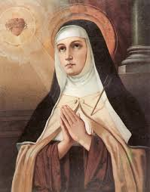

Christ has no body now but yours.
No hands, no feet on earth but yours.
Yours are the eyes through which He looks
with compassion on this world.
Yours are the feet
with which he walks to do good.
Yours are the hands
with which He blesses all the world.
Yours are the hands,
yours are the feet.
Yours are the eyes,
you are His body.
Christ has no body now but yours.
No hands, no feet on earth but yours.
Yours are the eyes through which He looks
with compassion on this world.
Christ has no body now on earth but yours.

Time of prayer

In assurance of his victory over sin and death,
let us pray to Jesus Christ our Lord and Saviour.

Light of the world,
Be present in all places of suffering, violence and pain,
And shine the light of your truth and love
Wherever there is darkness and evil:
Inspire us to continue your work
of redemption, reconciliation and justice.
Lord in your mercy, hear our prayer

Lord of the Church,
Empower by your Spirit all Christian people,
Remembering especially the leaders of the Church,
And in our diocese Bishop Keith and Archdeacons, Ian and Michael:
Grant them grace to proclaim the gospel joyfully in word and deed,
And may we all witness to your saving love.
Lord in your mercy, hear our prayer

Shepherd and Guardian of our souls;
Guide and enable all who lead and serve this community.
We pray especially for our volunteers and pastoral networks;
Enable us to use our talents and abilities
that we may serve one another and seek the welfare of all people.
Lord in your mercy, hear our prayer

Faithful Father,
We give thanks for the selfless and courageous service and sacrifice
of those who brought peace to Europe,
and for the good example they have given us;
May their example inspire us to serve
Using our talents and without counting the cost
That we may build a nation founded on hope, love and peace.
Lord in your mercy, hear our prayer

Great Physician,
Stretch out your hand to bring comfort, wholeness and peace
To all who suffer in body, mind or spirit:
Fill us with compassion that we may be channels of your healing love.
Lord in your mercy, hear our prayer

Conqueror of death,
We bring before you those who have died in the faith of Christ.
Have mercy on those who mourn and give them the sure hope of heaven.
Lord in your mercy, hear our prayer

Let us commend ourselves and all for whom we pray
to the mercy and protection of God, in the prayer our Saviour taught us.

Our Father who art in heaven
Hallowed be thy name.
Thy kingdom come, thy will be done
On earth as it is in heaven.
Give us this day our daily bread
And forgive us our trespasses
As we forgive those who trespass against us.
And lead us not into temptation
but deliver us from evil
For thine is the kingdom,
the power and the glory
For ever and ever. Amen.

A song to sing or reflect on:

Brother, sister, let me serve you
Let me be as Christ to you
Pray that I may have the grace to
Let you be my servant, too.

We are pilgrims on a journey
Fellow travellers on the road;
We are here to help each other
Walk the mile and share the load.

I will hold the Christlight for you
In the night-time of your fear;
I will hold my hand out to you,
Speak the peace you long to hear.

I will weep when you are weeping;
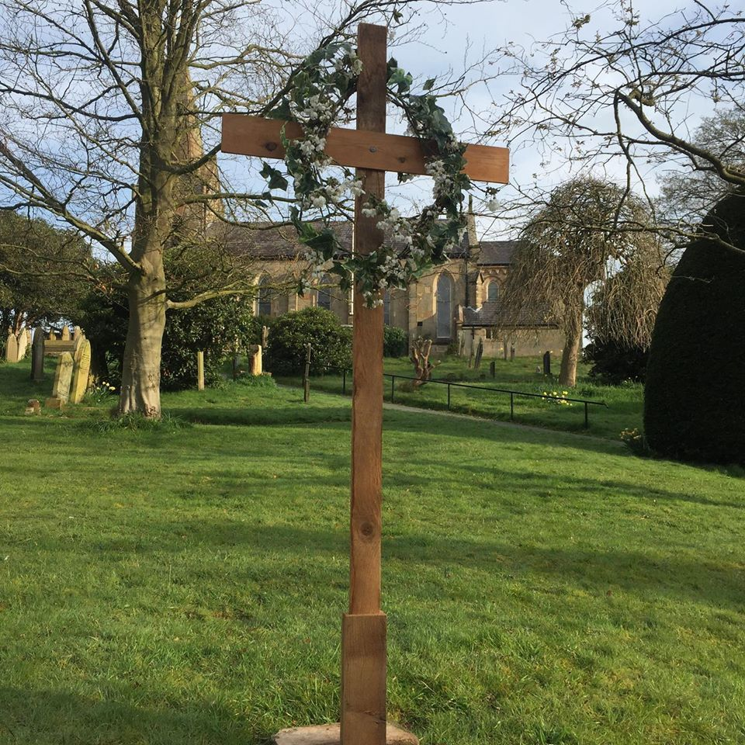
When you laugh I’ll laugh with you.
I will share your joy and sorrow
Till we’ve seen our journey though.

When we sing to God in heave
We shall find such harmony,
Born of all we’ve known together
Of Christ’s love and agony.

Brother, sister, let me serve you
Let me be as Christ to you
Pray that I may have the grace to
Let you be my servant, too.

Closing prayer
May the risen Christ grant us the joys of eternal life,
And may the blessing of God almighty,
the Father, the Son and the Holy Spirit,
be with you all this day and for ever more. Amen.

Go in peace to love and serve the Lord.
Thanks be to God.

