Ribbons of Remembrance

Resource for worship week 4

You will need some different coloured ribbons and a cross.

1 Thessalonians 3:12 ‘May the Lord make your love increase and overflow for each other and for everyone else, just as ours does for you.’

Read through slowly 1 Corinthians 13:1-13
If I speak in the tongues of men or of angels, but do not have love, I am only a resounding gong or a clanging cymbal. ² If I have the gift of prophecy and can fathom all mysteries and all knowledge, and if I have a faith that can move mountains, but do not have love, I am nothing. ³ If I give all I possess to the poor and give over my body to hardship that I may boast, but do not have love, I gain nothing.
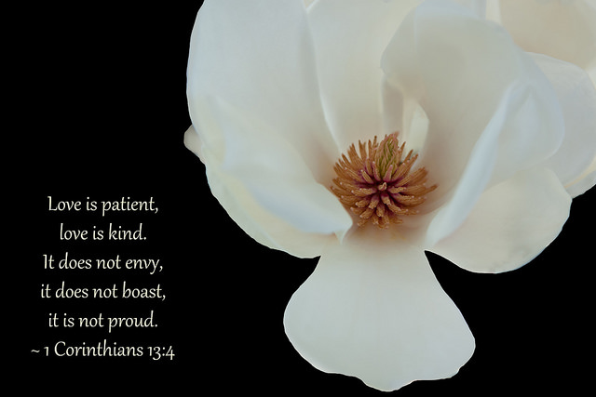
⁴ Love is patient, love is kind. It does not envy, it does not boast, it is not proud. ⁵ It does not dishonour others, it is not self-seeking, it is not easily angered, it keeps no record of wrongs. ⁶ Love does not delight in evil but rejoices with the truth. ⁷ It always protects, always trusts, always hopes, always perseveres.
⁸ Love never fails. But where there are prophecies, they will cease; where there are tongues, they will be stilled; where there is knowledge, it will pass away. ⁹ For we know in part and we prophesy in part, ¹⁰ but when completeness comes, what is in part disappears. ¹¹ When I was a child, I talked like a child, I thought like a child, I reasoned like a child. When I became a man, I put the ways of childhood behind me. ¹² For now we see only a reflection as in a mirror; then we shall see face to face. Now I know in part; then I shall know fully, even as I am fully known.
¹³ And now these three remain: faith, hope and love. But the greatest of these is love.

Reflection:
During this time of lockdown many have found time to reflect and re-evaluate what things are most important in their lives. Family time, friendship, community, many things we have perhaps taken for granted or have been pushed out by more ‘pressing concerns’ have now come to the fore. We are recognizing our need of one another and the importance of true love that is always there for us, no matter what. For the things we think are important are often temporary, they pass away like the morning cloud. Perhaps, its their very transience that gives them their importance, for we think we must seize the moment or it will be gone. But should we not invest most in that which will remain and endure for ever, that which is constant and will support us throughout all our lives – faith, hope and love.

Reflect on the following poem entitled Friendship by Marcia M Griffith

As I think of our friendship, I begin to see
Mere words can't describe what you mean to me.
When this cold, hard world has me lonesome and blue,
I look up to see my angel, my sweet angel, you.
You dry the tears that fall from my eyes.
You bring me sunshine to brighten my sky.
You rescue me when I'm scared and alone
And take my hand to lead me home.
No matter the miles that keep us apart,
We're always together in each other's hearts.
Sometimes we take for granted, I fear,
The ones who are so close and dear.
We get so caught up in life and things we must do.
Sometimes we forget to stop and say I love you.
If ever you felt I forgot or didn't care,
Let me stop right now; my true feelings I'll share.
You're the sun in my sky, the bed where I lie.
You're the home where I'm safe, the field where I play.
You're everything I am, everything I do.
So what I am saying is I LOVE YOU!

Prayer Activity
Take hold of a ribbon. Take a moment to remember someone who is especially important to you or someone whom the Lord has placed on your heart. Does the colour of the ribbon remind you of their character or something about them? Place the ribbon on the cross and say a pray of thankfulness for them and a prayer of petition. You may wish to repeat this for others as well. Afterwards you may take a particular ribbon and pin it to your jumper or coat to keep them in your heart and mind throughout the day. How might you show your friendship today to this person?

Time of prayer

In faith and hope we pray to our Lord
Who has overcome death and reigns in glory.

Merciful Father,
We pray for nurses, doctors and hospital staff,
those working in care settings
and for our emergency services.
May they be kept safe and supported,
So they can care for all who are unwell
to the best of their ability.
Lord in your mercy,
hear our prayer.

Gracious Lord,
We pray for all those who are called
to support families in times of bereavement;
Carers, funeral directors, ministers and social workers.
Comfort and uphold them as they comfort others
And grant them hope and peace.
Lord in your mercy,
Hear our prayer.

Lord of all kindliness,
We pray for those struggling mentally
With being confined at home.
Grant them peace and give them hope
Lord in your mercy,
Hear our prayer.

Lord of love,
We pray for our friends and neighbours
That you might bring us closer
Even though we are apart.
May we encourage and support each other
In prayer and in service.
Lord in your mercy,
Hear our prayer.

Lord of eternity,
In this moment we bring ourselves to you
We entrust to you our past, present and future,
Our memories, our dreams,
Our concerns and our joys:
Take them up in your hands
and cherish them close to your heart.
Lord in your mercy,
hear our prayer.

We commend ourselves,
and all for whom we pray,
to the mercy and protection of God.
Merciful Father,
accept these prayers
for the sake of your Son,
our Saviour Jesus Christ. Amen.

A song to sing or reflect on:

Make me a channel of your peace
Where there is hatred, let me bring your love
Where there is injury, your pardon Lord
And where there’s doubt, true faith in you.

O Master grant that I may never seek
So much to be consoled as to console
To be understood as to understand
To be loved as to love with all my soul.

Make me a channel of your peace.
Where there’s despair in life, let me bring hope.
Where there is darkness only light,
And where there’s sadness ever joy.

O Master grant that I may never seek
So much to be consoled as to console
To be understood as to understand
To be loved as to love with all my soul.

Make me a channel of your peace.
It is in pardoning that we are pardoned.
In giving to all men that we receive,
And in dying that we’re born to eternal life.

Closing prayer
May Christ,
who overcame sin and death, being raised to new life,
fill you with renewed hope and joy. Amen.

Go in peace to love and serve the Lord.
Thanks be to God.

