Words for the songs for Tuesday, Wednesday and Maundy Thursday.

Tuesday
Abba Father, Let Me Be
Yours And Yours Alone.
May My Will For Ever Be
Evermore Your Own.
Never Let My Heart Grow Cold,
Never Let Me Go
David Bilbrough © 1977 Thankyou Music

Wednesday
Seek ye first the kingdom of God
And his righteousness;
And all these things shall be added unto you,
Allelu, alleluia!
Alleluia, alleluia,
Alleluia, allelu, alleluia.

Ask, and it shall be given unto you,
Seek, and ye shall find.
Knock, and the door shall be opened unto you,
Allelu, alleluia!
Alleluia, alleluia,
Alleluia, allelu, alleluia.

You shall not live by bread alone,
But by every word
That proceeds from the mouth of the Lord,
Allelu, alleluia!
Alleluia, alleluia,
Alleluia, allelu, alleluia.
Karen Lafferty © 1972 CCCM Music/Maranatha! Music/CopyCare

Maundy Thursday
Broken For Me, Broken For You,
The Body Of Jesus, Broken For You.
He Offered His Body, He Poured Out His Soul;
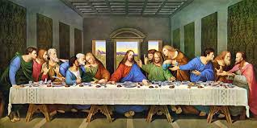
Jesus Was Broken, That We Might Be Whole:
Broken For Me…
Come To My Table And With Me Dine;
Eat Of My Bread And Drink Of My Wine:
Broken For Me…
This Is My Body Given For You;
Eat It Remembering I Died For You:
Broken For Me…
This is My Blood I shed for you,
For your forgiveness, making you new:
Broken For Me…
Janet Lunt © 1978 Sovereign Music UK

