Stepping-Stones.

Resource for worship week 2
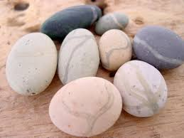

You will need some small pebbles or stones and a cross.

Psalm 119:105 ‘Your word is a lamp to my feet and a light for my path.’

Read through slowly Matthew 6:25-34
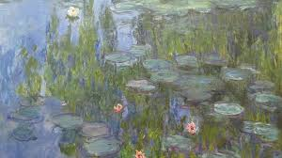

²⁵ “Therefore I tell you, do not worry about your life, what you will eat or drink; or about your body, what you will wear. Is not life more than food, and the body more than clothes? ²⁶ Look at the birds of the air; they do not sow or reap or store away in barns, and yet your heavenly Father feeds them. Are you not much more valuable than they? ²⁷ Can any one of you by worrying add a single hour to your life?
²⁸ “And why do you worry about clothes? See how the flowers of the field grow. They do not labour or spin. ²⁹ Yet I tell you that not even Solomon in all his splendour was dressed like one of these. ³⁰ If that is how God clothes the grass of the field, which is here today, and tomorrow is thrown into the fire, will he not much more clothe you? ³¹ So do not worry, saying, ‘What shall we eat?’ or ‘What shall we drink?’ or ‘What shall we wear?’ ³² For your heavenly Father knows that you need them. ³³ But seek first his kingdom and his righteousness, and all these things will be given to you as well. ³⁴ Therefore do not worry about tomorrow, for tomorrow will worry about itself. Each day has enough trouble of its own.

Reflection:

Confined to our homes, concerns about loved ones, confusion all around. Before us looms a huge mountain that seems impossible to climb. We are merely in the foothills and there are weeks of journey ahead. The enormity of what we are facing threatens our joy and takes away all our confidence. How are we to overcome?
Our Lord tells us to look around, as the arrival of Spring, the singing of birds and the blossom on the trees, speaks a different message to that on our TV’s. All around we see and hear signs of new life and we feel hope stirring in our hearts, for God is with us. ‘Do not worry,’ says our Lord. Consider how your heavenly Father cares for all creation – and for you. Seek after him and he will provide for all your needs. Do not fear tomorrow but rest in his love. Take one day at a time. We climb the mountain looking only to where we will next plant our feet; step by step. Soon we will look back and be amazed how far we have come and how faithful our God has been to us.

Prayer Activity

Take hold of a pebble. Think about the joys you have received this day. Give thanks to the Lord and place the pebble before the cross. Take another pebble and confess to the Lord the failings and omissions of the day, the words said in haste and the actin done without thinking. Lay the pebble before the cross. Finally, take a third pebble and lift to the Lord the concerns you have on your heart and mind for yourself and for others. Lay the pebble once more before the cross. Take a moment to entrust all your day to the God who loves you.
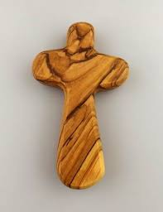

Reflect on the following poem entitled footprints by Mary Fishback Powers

One night a man had a dream
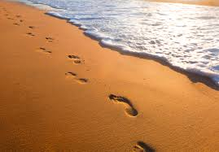
that he was walking along the beach with the Lord.
Across the dark sky flashed scenes from his life.
For each scene, he noticed
two sets of footprints in the sand,
one belonging to him and the other to the Lord.
When the last scene of his life flashed before him,
He looked back at the footprints in the sand.
And he noticed that many times
along the path of his life
there was only one set of footprints.
And he also noticed that this happened
at the very lowest and saddest times of his life.
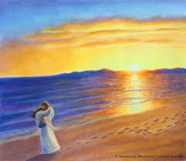
This really bothered him
and he questioned the Lord about it.
‘Lord, you told me that once I decided to follow you,
you would walk with me all the way.
But I have noticed that during
the most troublesome times of my life,
there is only one set of footprints.
I don’t understand why, when I needed you most,
you would leave me.’
‘My precious, precious child,’ he whispered.
I love you and would never leave you.
When you looked back
and saw only one set of footprints,
it was then that I carried you.’

If you feel the journey is too difficult, look to the Lord and ask him to take you up in his arms. Then pick up the phone and ask a friend to pray with you. You will bless them and yourself.

Time of prayer

Let us pray to the Lord,
who is our refuge and stronghold.
For the health and well-being of our nation,
that all who are fearful and anxious
may be at peace and free from worry:
Lord, hear us,
Lord, graciously hear us.
For the isolated and housebound,
that we may be alert to their needs,
and care for them in their vulnerability:
Lord, hear us,
Lord, graciously hear us.
For our homes and families,
our schools and young people,
and all in any kind of need or distress:
Lord, hear us,
Lord, graciously hear us.
For a blessing on our local community,
that our neighbourhoods may be places of trust and friendship,
where all are known and cared for:
Lord, hear us,
Lord, graciously hear us.
We commend ourselves, and all for whom we pray,
to the mercy and protection of God.
Merciful Father,
accept these prayers
for the sake of your Son,
our Saviour Jesus Christ. Amen.

A song to sing or reflect on:

The Lord’s my shepherd, I’ll not want
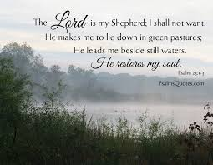
He makes me lie in pastures green.
He leads me by the still, still waters,
His goodness restores my soul.

And I will trust in You alone
And I will trust in You alone
For Your endless mercy follows me,
Your goodness will lead me home.

He guides my ways in righteousness,
And He anoints my head with oil,
And my cup, it overflows with joy,
I feast on His pure delights.

And though I walk the darkest path,
I will not fear the evil one,
For You are with me, and Your rod and staff
Are the comfort I need to know.

Closing prayer
May God give you his comfort and his peace,
His light and his joy,
His strength and his love. Amen.

Go in peace to love and serve the Lord.
Thanks be to God.

