Bearing Fruit

Resource for worship week 15

You will need a cross and a small bunch of grapes

Opening verse:
‘Taste and see that the Lord is good; blessed is the one who takes refuge in him.’ Psalm 34:8

Read through slowly the familiar verses from John 15:5-8 below:

⁵ “I am the vine; you are the branches. If you remain in me and I in you, you will bear much fruit; apart from me you can do nothing.

⁶ If you do not remain in me, you are like a branch that is thrown away and withers; such branches are picked up, thrown into the fire and burned.

⁷ If you remain in me and my words remain in you, ask whatever you wish, and it will be done for you.

⁸ This is to my Father’s glory, that you bear much fruit, showing yourselves to be my disciples.

Reflection:
Jesus has called us to be his disciples and his desire is that the quality of our lives; our holiness, goodness, love, joy, peace, patience, kindness, faithfulness and self-control, bears witness to him and brings glory to God. As the quality of the grape points to the health of the vine, so the quality of our lives shows the beauty of Christ. Therefore, he exhorts us to be firmly established in him, as a branch is grafted into the vine. As the sap flows through the vine into the branches to nourish the fruit, so God’s loving grace flows through Jesus into us.
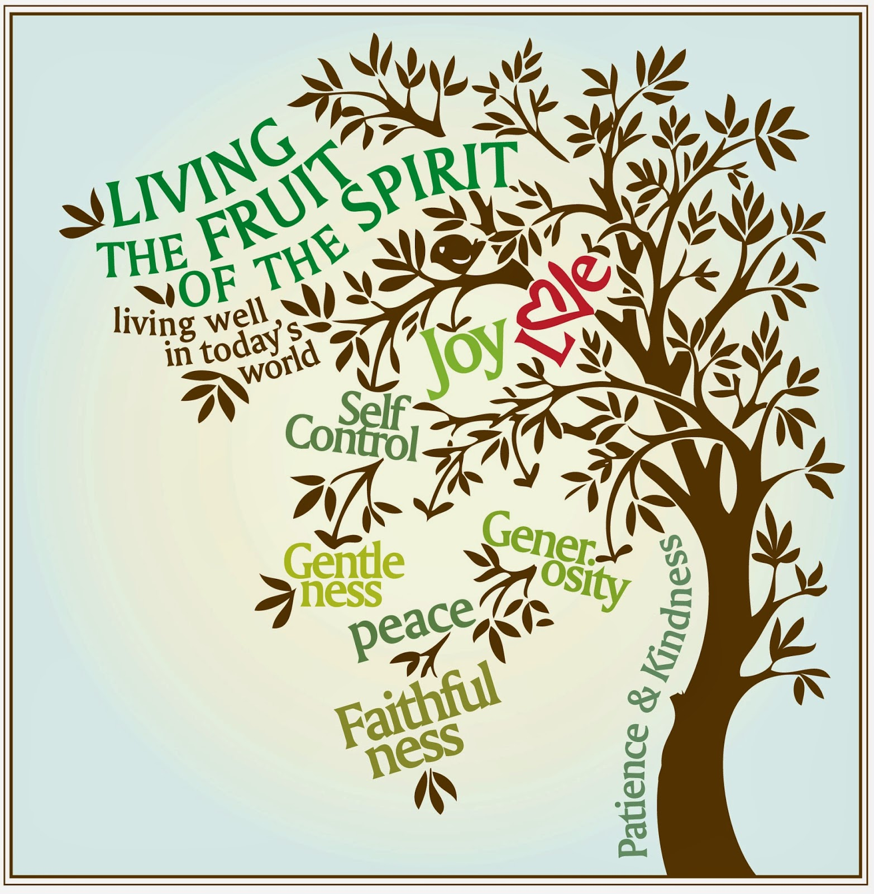

The means by which we receive this grace is prayer. As we remain in Christ and take to heart his promises, praying them into our lives, so we draw all the goodness of Jesus, into our souls and bear fruit for him. Jesus will not withhold any good from us even as a vine will not withhold its sap from a thirsty branch. The more we ask the more we receive, the more we are in need, the more our Lord will provide. ‘Ask whatever you wish, and it will be done for you.’

There is a deep mystery to prayer, but surely the greatest mystery is why we do not pray more fervently and faithfully. ‘Ask and it will be given to you; seek and you will find; knock and the door will be opened to you.’

Prayer Activity
Take the grapes in the palm of your hand. Taste one and consider how delightful it is to eat. Think about your prayer life and the joy you have in prayer. Reflect on the words of the Psalmist ‘Taste and see that the Lord is good.’
Your grapes are probably seedless, for many do not like the pips. Think of how the most important part of the grape is the seed, which can bring forth even greater fruitfulness. Does the fruit we bear in our lives have the seed of God at the centre?

You may wish to pray the following prayer:

Heavenly Father,
I pray that I may grow in grace day by day.
I pray that in every area of my life I may be more fruitful
And grow more like the Lord Jesus Christ.
I know that there is much within me
that needs to be rooted out and tended.
Search me and examine my heart and my attitude;
Fill me with your goodness and holiness.
Help me to pray and to trust in all your promises,
So that my life, my word, my thoughts and actions
May show forth your love in all things
and bear the seed of your gospel.
This I ask in Jesus' name and for your glory. Amen.

Quote from St. Chrysostom

The potency of prayer hath subdued the strength of fire;
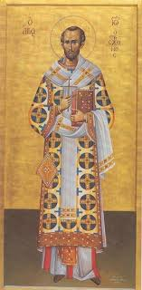
it had bridled the rage of lions,
hushed the anarchy to rest,
extinguished wars, appeased the elements,
expelled demons, burst the chains of death,
expanded the gates of heaven, assuaged diseases,
repelled frauds, rescued cities from destruction,
stayed the sun in its course,
and arrested the progress of the thunderbolt.
Prayer is an all-efficient panoply,
a treasure undiminished, a mine which is never exhausted,
a sky unobscured by clouds, a heaven unruffled by the storm.
It is the root, the fountain, the mother of a thousand blessings.

Time of prayer
We pray that Christ may be seen in the life of the Church.
Jesus, Lord of the Church,
in your mercy, hear us.

You have called us into the family of those who are
the children of God.
May our love for our brothers and sisters
be strengthened by your grace.
Jesus, Lord of the Church,
in your mercy, hear us.

You have called us to be a temple
where the Holy Spirit can dwell.
Give us clean hands and pure hearts,
so that our lives will reflect your holiness.
Jesus, Lord of the Church,
in your mercy, hear us.

You have called us to be a light to the world,
so that those in darkness come to you.
May our lives shine
as a witness to the saving grace you have given for all.
Jesus, Lord of the Church,
in your mercy, hear us.

You have called us to be members of your body,
so that when one suffers, all suffer together.
We ask for your comfort and healing power
to bring hope to those in distress.
Jesus, Lord of the Church,
in your mercy, hear us.

You have called us to be the Bride,
where you, Lord, are the Bridegroom.
Prepare us for the wedding feast,
where we will be united with you for ever.
Jesus, Lord of the Church,
hear our prayer,
and make us one in heart and mind
to serve you with joy for ever. Amen.

O God the protector of all who trust in you
Without whom nothing is strong, nothing is holy:
Increase and multiply upon us your mercy,
That with you as our ruler and guide
We may so pass through things temporal
That we lose not our hold on things eternal.
Grant this heavenly father
for our Lord Jesus Chris’s sake
who is alive and reigns with you
in the unity of the Holy Spirit
one God, now and forever. Amen.

Let us commend ourselves and all for whom we pray
to the mercy and protection of God, in the prayer our Saviour taught us.

Our Father who art in heaven,
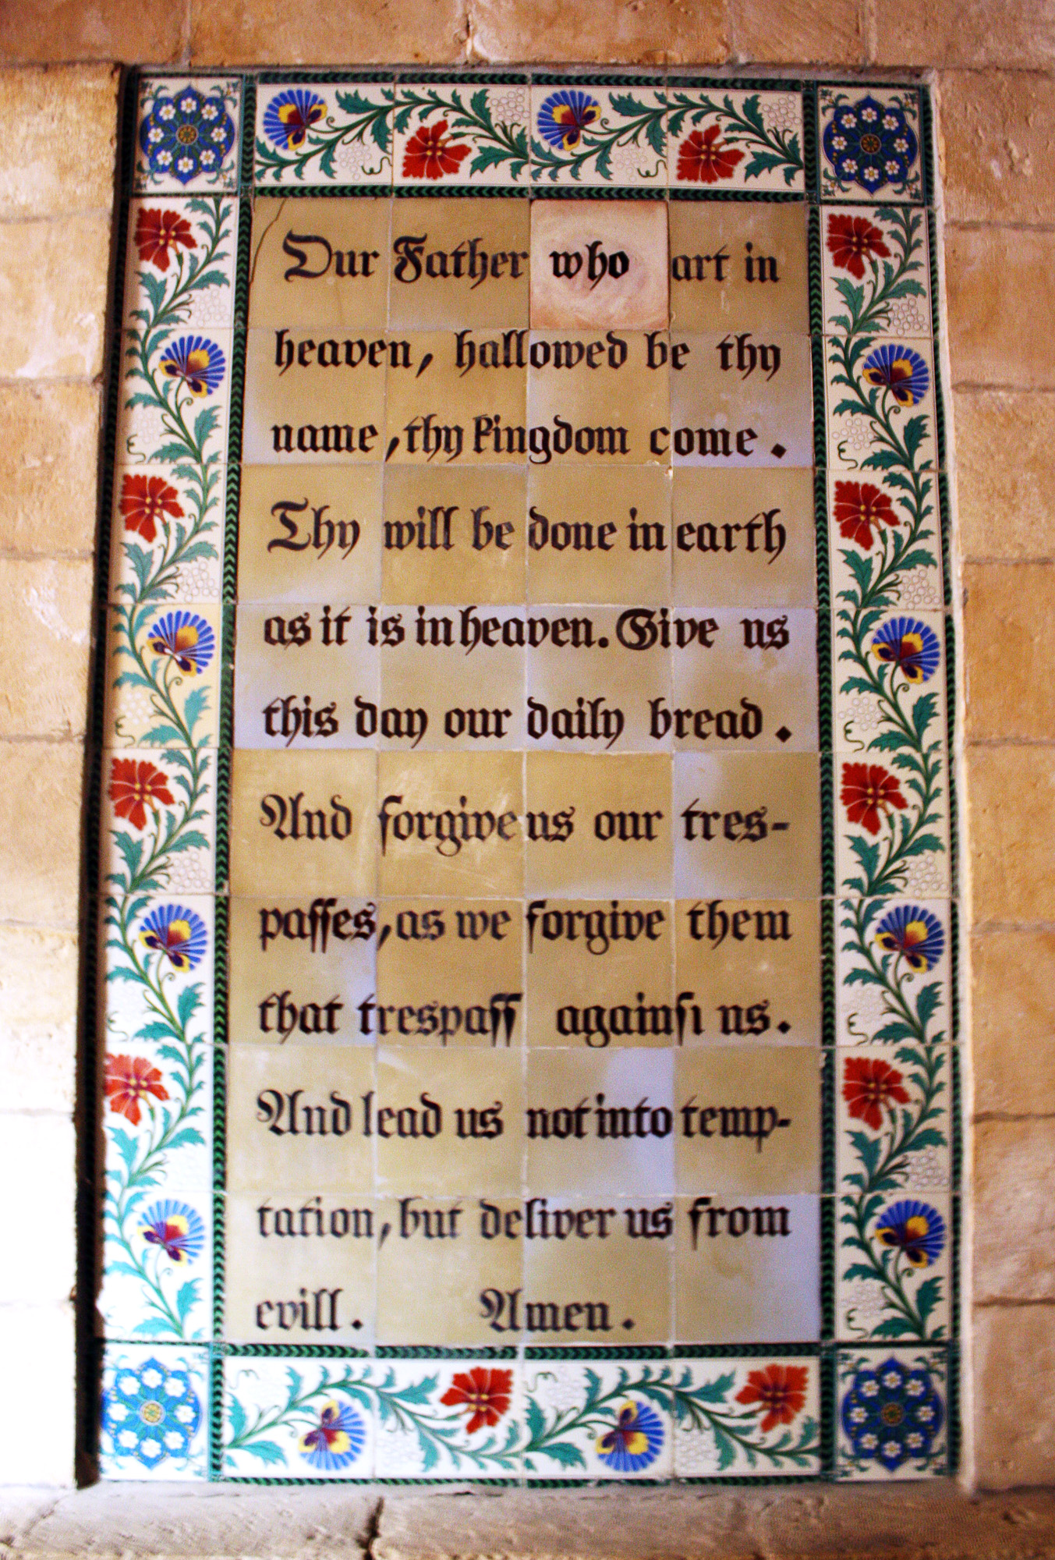
Hallowed be thy name.
Thy kingdom come,
thy will be done on earth as it is in heaven.
Give us this day our daily bread
and forgive us our trespasses
As we forgive those who trespass against us.
And lead us not into temptation
but deliver us from evil
For thine is the kingdom,
the power and the glory
For ever and ever. Amen.

A song to sing or reflect on:

The day Thou gavest Lord is ended
The darkness falls at Thy behest
To Thee our morning hymns ascended
Thy praise shall sanctify our rest.

We thank Thee that Thy Church unsleeping
While earth rolls onward into light
Through all the world, her watching is keeping
And rests not now by day or night.

As o’er each continent and island
The dawn leads on another day
The voice of prayer is never silent
Nor dies the strain of praise away.

The sun that bids us rest is waking
Our brethren ‘neath the western sky
And hour by hour fresh lips are making
Thy wondrous doings heard on high.

Closing prayers
You are called and loved by God the Father
And kept safe by Jesus Christ.
Mercy, peace and love be yours in abundance
From God the Father, Son and Holy Spirit. Amen.

