Shining Lights

Resource for worship week 11
You will need a cross and a star emblem.

Opening verse:
‘Then you will shine among them like stars in the sky.’ Philippians 2:15

Read through slowly the verses from Philippians 2:1-4 below:

¹Therefore if you have any encouragement from being united with Christ, if any comfort from his love, if any common sharing in the Spirit, if any tenderness and compassion,

² then make my joy complete by being like-minded, having the same love, being one in spirit and of one mind.

³ Do nothing out of selfish ambition or vain conceit. Rather, in humility value others above yourselves,

⁴ not looking to your own interests but each of you to the interests of the others.

Reflection:
During this period of lockdown our spirits have been uplifted by the examples of those who have selflessly given of themselves and brought great encouragement to others. One person in particular springs to mind is Captain Tom Moore, who through his determination to walk 100 lengths of his house before his 100th birthday raised 33 million pounds for NHS hospitals. Arguably more important that the money, he captured the heart of the nation in its desire to support our health care workers and encouraged us all to be of one spirit and one mind. He looked not to his own interests but to the interests of others. He also demonstrated that age is no barrier to serving and given the opportunity we can all shine like stars in the sky.
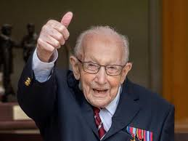

As we face another week of restrictions, it can sap our spirits and make us despondent. Rather than yielding to these feelings, let us instead give thanks for those who have been ‘shining stars’ in our lives; those who have brought us joy and encouragement through simple acts of kindness. Let us consider how we might bring a ray of sunshine into the lives of those around us.
Prayer Activity
Take a moment to think of someone who has been a ray of sunshine, ‘a shining star’ to you in the past few weeks. Take your star and hold it before the cross. Say a prayer of thanks to God for them. Tell the Lord how you felt before they came and how you feel now, when you think of them. Pray that the Lord would inspire in us all this spirit of unity and loving service that we might encourage and bring joy to one another, as children of God.
You may wish to pray the following prayer:

Lord God, gracious Father
I thank you for those you bring near to me
to comfort and encourage me,
to guide and assure me of your love.
In particular I give thanks for…
He/ She has been a precious gift from you to me,
A light to guide, a companion on the way,
A shoulder to lean on and a friend with whom I can confide.
Be ever near and bless him/her for all the kindness shown.
In thankfulness and in Jesus name. Amen.

Poem: Jesus is waiting provided by Janet Parkinson

Jesus Christ is waiting,
Waiting in the streets;
No one is his neighbour,
All alone he eats.
Listen, Lord Jesus,
I am lonely too.
Make me, friend or stranger,
Fit to wait on you

Jesus Christ is healing,
Healing in the streets;
Curing those who suffer,
Touching those he greets.
Listen, Lord Jesus,
I have pity too.
Let my care be active,
Healing just like you.

Jesus Christ is dancing,
Dancing in the streets,
Where each sign of hatred
He, with love, defeats.
Listen, Lord Jesus,
I should triumph too.
On suspicion’s graveyard
Let me dance with you.

Jesus Christ is calling,
Calling in the streets,
”Who will join my journey?
I will guide their feet.”
Listen, Lord Jesus,
Let my fears be few.
Walk one step before me;
I will follow you.

Time of prayer
Almighty God, our heavenly Father,
you have taught us to love and serve one another:
Give us eyes of compassion for those who are suffering
And open hearts to all who are in need;
especially for those who are closest to our doors.
Save us from neglecting opportunities to help
And grant us time and energy to do all that is good
for the sake of our Lord Jesus.
Lord, hear us,
Lord, graciously hear us.

Most loving Father,
who calls us to cast all our cares upon you,
because you care for us;
Preserve us from faithless fears and anxieties,
And grant that no dark clouds or storms of unrest
will hide us from your light or keep us from your love,
that we may rest safe and secure in you.
Lord, hear us,
Lord, graciously hear us.

Lord of mercy,
Teach us to be merciful,
To see people through kind eyes
And not with suspicious hearts;
To hear people with discernment
And not with judgemental attitudes;
To seek the best in all people
And to be gracious and gentle in rebuke.
Lord, hear us,
Lord, graciously hear us.
Lord Jesus, who through the Holy Spirit
Endows your servants with many gifts
For the benefit of the church;
Grant us grace to use the talents and skills we have been given
to serve others and to bring glory to you.
Lord, hear us,
Lord, graciously hear us.
God of all compassion
We pray for all who are suffering from illness,
are terminally ill or mourning the loss of a loved one:
Gather them up in your arms
and carry them close to your heart,
that in all their situations they may know your presence
and experience your love
Lord, hear us,
Lord, graciously hear us.
Let us commend ourselves and all for whom we pray
to the mercy and protection of God, in the prayer our Saviour taught us.

Our Father who art in heaven,
Hallowed be thy name.
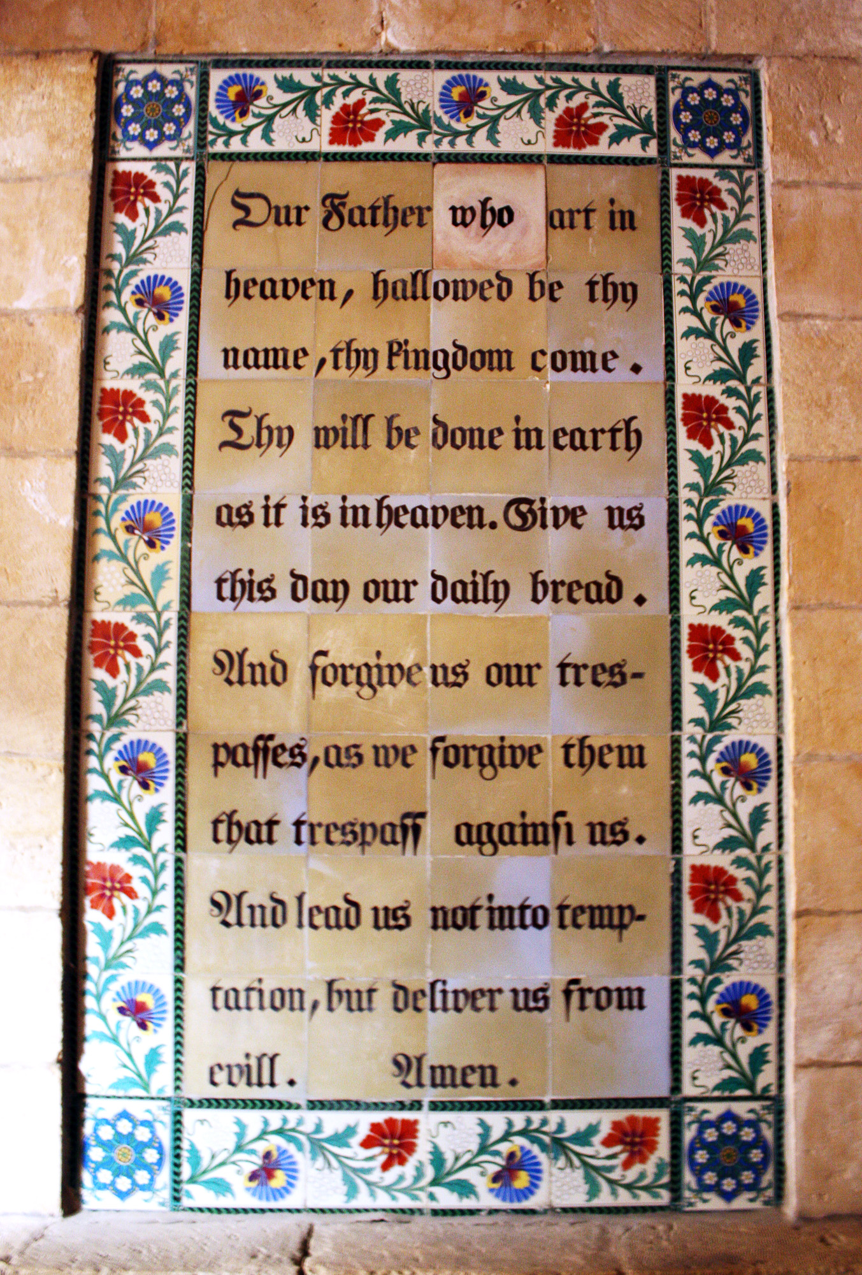
Thy kingdom come, thy will be done
On earth as it is in heaven.
Give us this day our daily bread and forgive us our trespasses
As we forgive those who trespass against us.
And lead us not into temptation but deliver us from evil
For thine is the kingdom, the power and the glory
For ever and ever. Amen.

A song to sing or reflect on:

Will you come and follow me
if I but call your name?
Will you go where you don’t know
and never be the same?
Will you let my love be shown,
will you let my name be known,
will you let my life be grown
in you and you in me?

Will you leave yourself behind
if I but call your name?
Will you care for cruel and kind
and never be the same?
Will you risk the hostile stare
should your life attract or scare?
Will you let me answer prayer
in you and you in me?

Will you let the blinded see
if I but call your name?
Will you set the prisoners free
and never be the same?
Will you kiss the leper clean
and do such as this unseen,
and admit to what I mean
in you and you in me?

Will you love the ‘you’ you hide
if I but call your name?
Will you quell the fear inside
and never be the same?
Will you use the faith you’ve found
to reshape the world around
through my sight and touch and sound
in you and you in me?

Lord, your summons echoes true
when you but call my name.
Let me turn and follow you
and never be the same.
In your company I’ll go
where your love and footsteps show.
Thus I’ll move and live and grow
in you and you in me.

Closing prayers
Gracious God, you have given us much today:
Grant us also a thankful spirit.
Into your hands we commend ourselves and those we love.
Stay with us, and when we take our rest
Renew us for the service of your Son Jesus Christ. Amen.

May the Lord of peace himself
Give you peace at all times and in every way.
The Lord be with you all, for evermore. Amen.

