Supporting Charities

Resource for worship week 7

You will need an item that represents a charity close to your heart and a cross.

Opening verse:

‘These three remain: faith, hope and love. But the greatest of these is love.’ 1 Cor. 13:13

Read through slowly the verses from Isaiah 58:6-10 below:

⁶“Is not this the kind of fasting I have chosen: to loose the chains of injustice
and untie the cords of the yoke, to set the oppressed free and break every yoke?
⁷ Is it not to share your food with the hungry and to provide the poor wanderer with shelter—
when you see the naked, to clothe them, and not to turn away from your own flesh and blood?
⁸ Then your light will break forth like the dawn, and your healing will quickly appear;
then your righteousness will go before you, and the glory of the Lord will be your rear guard.
⁹ Then you will call, and the Lord will answer; you will cry for help, and he will say: Here am I.
“If you do away with the yoke of oppression, with the pointing finger and malicious talk,
¹⁰ and if you spend yourselves in behalf of the hungry and satisfy the needs of the oppressed,
then your light will rise in the darkness, and your night will become like the noonday.

Reflection:
Sometimes the Lord takes us out of our daily routines to give us a new perspective, even an awakening to the needs of these around us. These past few weeks we have come to value one another in deeper ways and perhaps appreciate even more fully the work of our charitable organisations. The human cost of this Coronavirus pandemic is incalculable as it continues to inflict physical suffering, emotional distress and economic hardship across the world. Not since the Second World War have communities needed to come together in solidarity to support and uphold one another – and our charities are vital links in the chain.
May 10th marks the beginning of Christian Aid Week, when many would be visiting door-to-door or hosting events to raise funds to support individuals and communities across the world. The current restrictions prevent us from doing this and highlight the growing pressure that is on charities as they seek to bring aid to the most vulnerable people in society. Yet, it is that very work, carried out selflessly in times of crisis that reveals the true nature of our hearts and demonstrates that we are children of God.

Our Lord promises that when we walk in his ways and love as he loves, then the earth will receive a blessing, the nations will govern with justice, the oppressed will be set free, the hungry will be satisfied, the sick will be healed and darkness will be no more, for the light of the Lord will shine upon his people and they will walk in his presence for ever more.

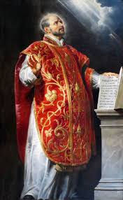
A prayer of St Ignatius of Loyola:

Lord, teach me to be generous;
Teach me to serve you as you deserve;
To give and not to count the cost;
To fight and not to heed the wounds;
To toil, and not to seek for rest;
To labour, and not to ask for reward -
save that of knowing that I am doing your will.

Prayer Activity

Take a moment to think about a charity or group close to your heart.
Place a symbol representing this organisation before the cross. Give thanks for them and pray for their work in the community and/or across the world. Pray also for the people they seek to serve especially at this difficult time. You may wish to use the following prayers:

Heavenly Father,
Whose Son came to preach good news to the poor,
To bind up the broken-hearted, to proclaim freedom for those in captivity,
Deliverance for those in darkness and to announce the time of God’s favour:
I give you thanks for the work of ...
Continue their work of loving service
amongst the poor, the disabled, the vulnerable and marginalised.
Uphold and care for all those in need
That they may receive grace to help them in their need, and
be brought into the glorious light of your kingdom. Amen.
Time of prayer
O Holy Spirit of love, quicken our imaginations
that we may feel more deeply for the needs of others
as we put ourselves in their place.
Give us hearts of self-forgetting compassion
which will move us to give from that which you have given us,
and to be good neighbours to those both near and far,
for the sake of him who taught us that it is more blessed to give than receive,
even Jesus our Lord. Amen.

Prayer for those in slavery
Loving Father, who came to set the prisoner free;
We pray for all who are exploited and enslaved;
For those forced into labour, trafficked into sexual slavery, and denied freedom.
Lord release them from their chains.
Grant them protection, safety, and empowerment.
Restore their dignity and provide them a new beginning.
Show us how we might end exploitation by addressing its causes.
Help us reach out in support of victims and survivors of human trafficking.
Make us instruments of your spirit for their liberation.
Lord in your mercy, hear our prayer

Prayer for the disabled
Lord Jesus, you cared for those who were blind or deaf, crippled or slow to learn.
Give special care, we pray, to those who are disabled,
Particularly those we name in the silence of our hearts…
May they experience dignity, acceptance of equality and self-sufficiency in their lives,
May they be supported without discrimination or prejudice, and
By our concern may they know and experience the love you have for them
Lord in your mercy, hear our prayer.

Prayer for those trapped in poverty
Heavenly Father, whose eyes are always on the poor
Remember with mercy those who are destitute, homeless, or trapped in poverty:
We pray for those sleeping rough on park benches, in doorways or bus stations;
For parents who cannot afford to provide food for their children.
For those who have lost jobs and cannot meet their mortgage or rental payments.
For those who have no relatives or friends to support and care for them
For those who feel let down by government and society.
Lord, we pray that you will provide shelter, food, security and hope for all in need.
Motivate and empower us to bring about justice and support for the poor.
Lord in your mercy, hear our prayer.
Prayer for those in mental distress
Loving God, who brings peace to those trouble in mind or spirit;
we pray for those who confronted by the sadness, ambiguity and confusion of mental illness,
and for those upon whom they depend for attention and compassionate care.
Look with mercy on all, whose afflictions bring them weakness,
distress, confusion or isolation.
Provide for them homes of dignity and peace;
give to them understanding helpers and the willingness to accept help.
Lord in your mercy, hear our prayer

Prayer for the sick and grieving
Loving Lord, who has compassion on the sick and sorrowing:
We pray for all who are unwell, have a long term illness or condition,
Those who are terminally ill and those who are mourning the loss of a loved one.
Be with them in their distress and suffering,
Comfort and console them and their carers
And grant them patience, peace and hope in their troubles.
Lord in your mercy, hear our prayer

Let us commend ourselves and all for whom we pray
to the mercy and protection of God, in the prayer our Saviour taught us.

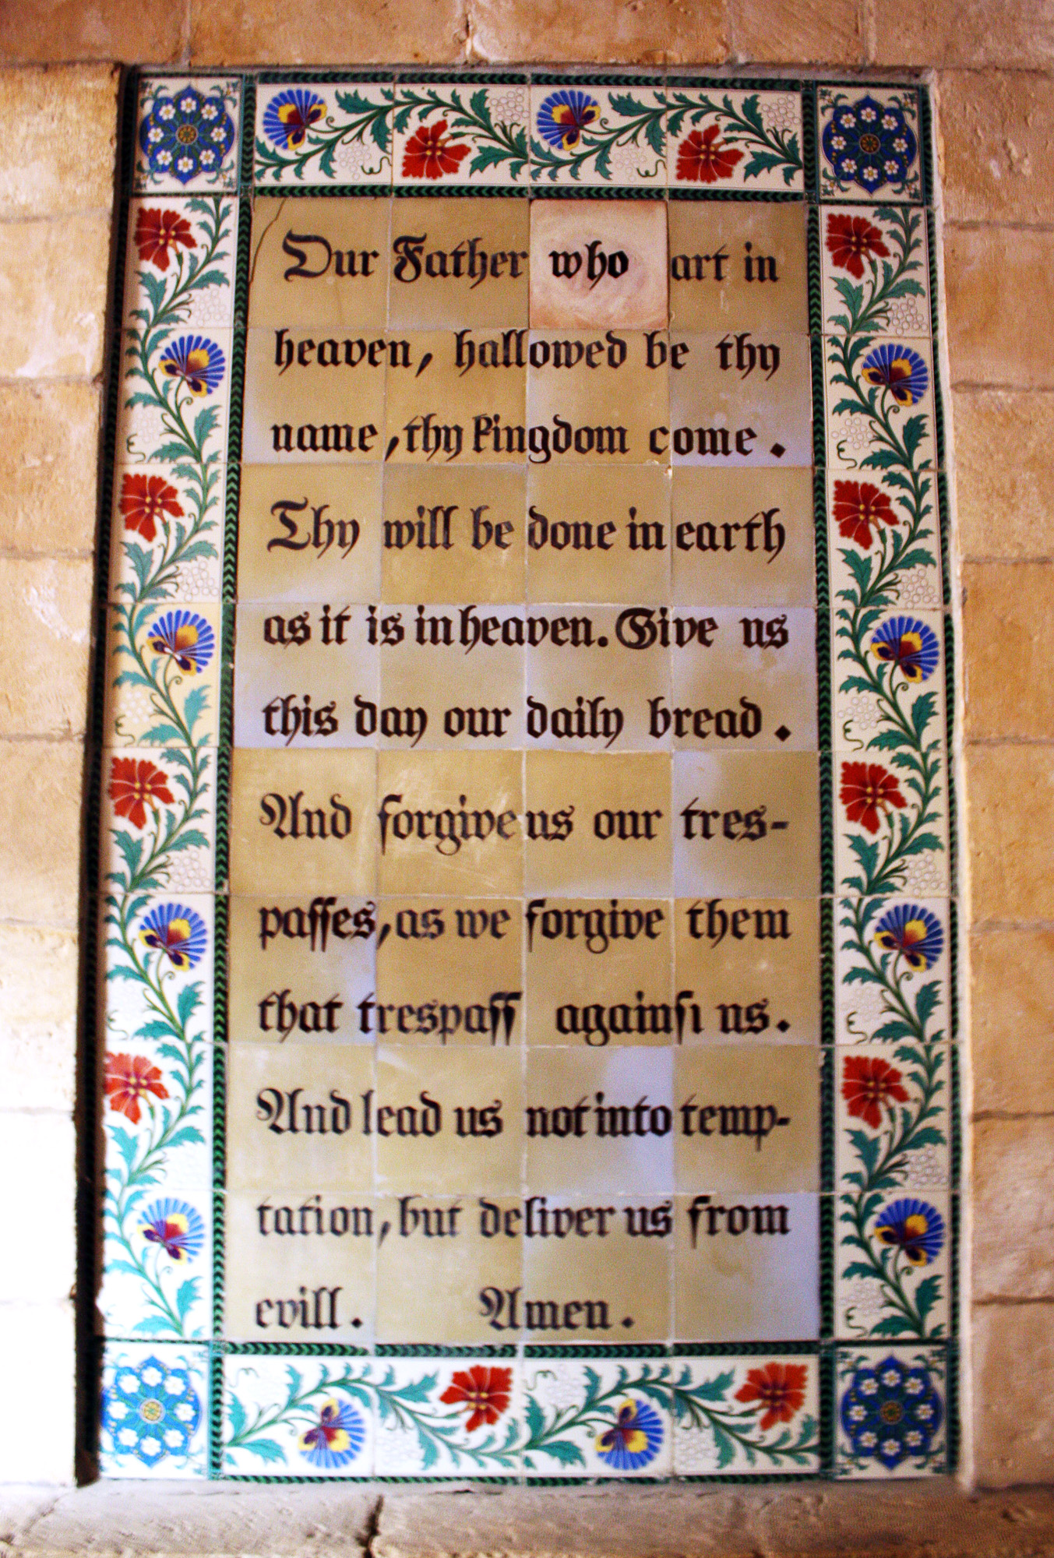
Our Father who art in heaven
Hallowed be thy name.
Thy kingdom come, thy will be done
On earth as it is in heaven.
Give us this day our daily bread
And forgive us our trespasses
As we forgive those who trespass against us.
And lead us not into temptation
but deliver us from evil
For thine is the kingdom,
the power and the glory
For ever and ever. Amen.

A song to sing or reflect on:

As the deer pants for the water
So my soul longs after you
You alone are my hearts desire
And I long to worship you

Chorus:
you alone are my strength , my shield
To you alone may my spirit yield
You alone are my hearts desire
And I long to worship you

I want you more than gold or silver
Only you can satisfy
You alone are the real joy giver
And the apple of my eye

Chorus:

You are my friend and you are my brother
Even though you are king
I love you more than any other
So much more than anything.

Chorus:

Closing prayer
May God who clothes the lillies and feeds the birds of the sky,
Who leads the lambs to pasture and the deer to water,
Clothe us, feed us, refresh us and bless us with his rest
Now and for ever more. Amen.

Go in peace to love and serve the Lord.
Thanks be to God.

To support the work of Christian Aid, please visit https://www.christianaid.org.uk/appeals/key-appeals/christian-aid-week

